

**Semester One Examination 2017**

**Question/Answer Booklet**

**MATHEMATICS**

**METHODS UNIT 3**

**Section One:**

**Calculator-free**

|  |
| --- |
| Student Name: _____________________________________ |
| Teacher‘s Name: _____________________________________ |
|  |

**Time allowed for this section**

Reading time before commencing work: five minutes

Working time for paper: fifty minutes

**Material required/recommended for this section**

**To be provided by the supervisor**

This Question/Answer booklet

Formula Sheet

**To be provided by the candidate**

Standard items: pens(blue/black preferred), pencils(including coloured), sharpener, correction tape/fluid, erasers, ruler, highlighters

Special Items: nil

**Important note to candidates**

No other items may be taken into the examination room. It is **your** responsibility to ensure that you do not have any unauthorised notes or other items of a non-personal nature in the examination room. If you have any unauthorised material with you, hand it to the supervisor **before** reading any further.

**Structure of this paper**

|  |  |  |  |  |  |
| --- | --- | --- | --- | --- | --- |
|  | Number of questions available | Number of questions to be attempted | Suggested working time (minutes) | Marks available | % |
| **Section One**  **Calculator—free** | **8** | **8** | **50** | **52** | **35** |
| Section Two  Calculator—assumed | 14 | 14 | 100 | 98 | 65 |
|  | | | | 150 | 100 |

**Instructions to candidates**

1. The rules for the conduct of Western Australian external examinations are detailed in the *Year 12 Information Handbook 2017.* Sitting this examination implies that you agree to abide by these rules.
2. Answer the questions according to the following instructions.

Section One: Write answers in this Question/Answer Booklet. Answer **all** questions.

**Show all your working clearly.** Your working should be in sufficient detail to allow your

answers to be checked readily and for marks to be awarded for reasoning. Incorrect

answers given without supporting reasoning cannot be allocated any marks. For any

question or part question worth more than two marks, valid working or justification is

required to receive full marks. If you repeat an answer to any question, ensure that you

cancel the answer you do not wish to have marked.

It is recommended that you **do not use pencil**, except in diagrams.

1. You must be careful to confine your responses to the specific questions asked and to follow any instructions that are specific to a particular question.
2. Spare pages are included at the end of this booklet. They can be used for planning your responses and/or as additional space if required to continue an answer.

* Planning: If you use the spare pages for planning, indicate this clearly at the top of the

page.

* Continuing an answer: If you need to use the space to continue an answer, indicate in the original answer space where the answer is continued, i.e. give the page number. Fill in the number of the question that you are continuing to answer at the top of the page.

1. The Formula Sheet is **not** handed in with your Question/Answer Booklet.

# Section One: Calculator–free 52 marks

This section has **eight (8)** questions. Attempt **all** questions. Write your answers in the spaces provided.

Spare pages are included at the end of this booklet. They can be used for planning your responses and/or as additional space if required to continue an answer.

* Planning: If you use the spare pages for planning, indicate this clearly at the top of the page.
* Continuing an answer: If you need to use the space to continue an answer, indicate in the original answer space where the answer is continued, i.e. give the page number. Fill in the number of the question(s) that you are continuing to answer at the top of the page.

Working time: 50 minutes

**Question 1 (7 marks)**

**(a)** The line 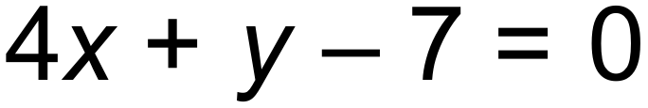 is parallel to the tangent to the curve 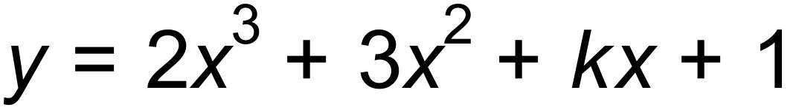 at 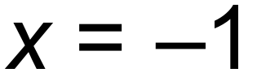. Determine the value of *k.* (2 marks)

**(b)** Let . Determine 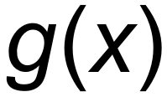 in terms of *h*(*x*). (2 marks)

**(c)** Find 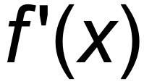 when 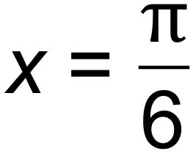, given that 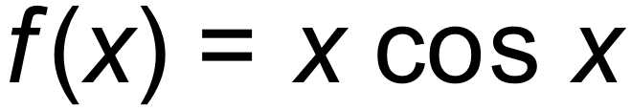. (3 marks)

**Question 2 (7 marks)**

The discrete random variable X has a mean of 0.3, a variance of 0.61 and the following probability distribution.

|  |  |  |  |
| --- | --- | --- | --- |
| X |  | 0 | 1 |
|  | a | b | 0.5 |

**(a)** (i) Find a and b. (2 marks)

(ii) Find 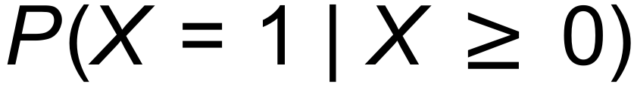. (1 mark)

**(b)** The random variable *X* is transformed to the random variable *Y* according to the equation 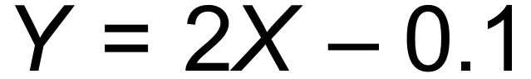

(i) Determine the expected value and the variance of the random variable *Y*. (2 marks)

(ii) Evaluate 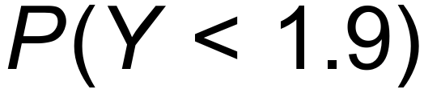. (1 mark)

**(c)** Explain the relationship between the standard deviation of *X* and the

standard deviation of *Y*. (1 mark)

**Question 3 (4 marks)**

The graph of the function 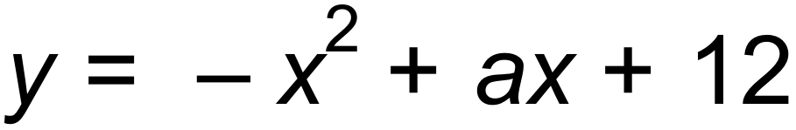 is shown below. If *b* and *c* are the *x*-intercepts

of the function and the shaded area is 45 units2, show that 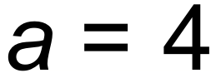 and find the values of *b* and *c.*

(4 marks)

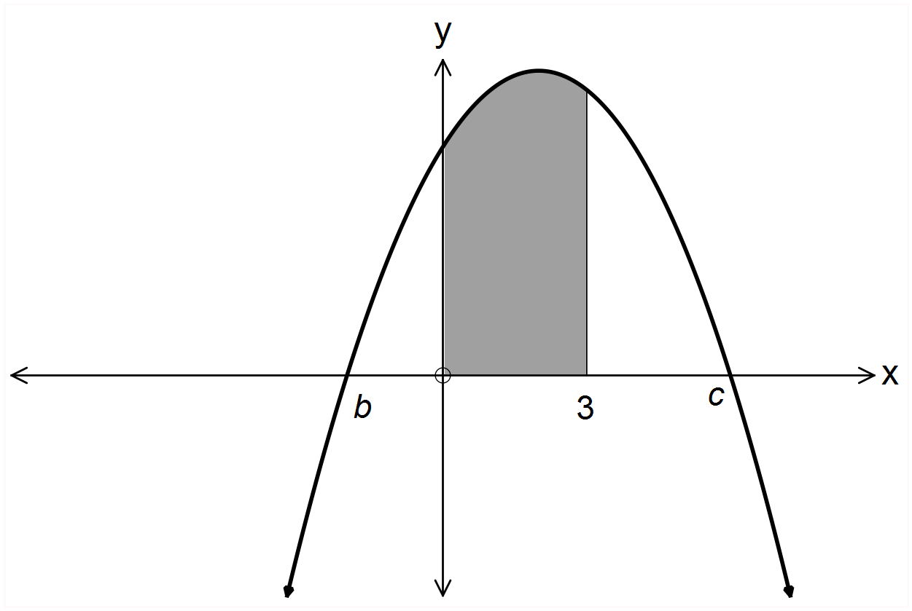

**Question 4 (3 marks)**

Given that *y* = *x ex*, find 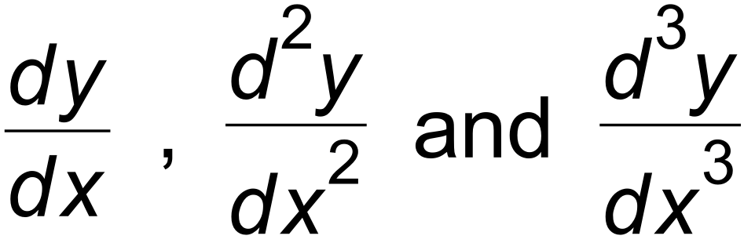

Hence, suggest a formula for 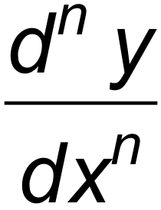 where *n* is a positive integer. (3 marks)

**Question 5 (7 marks)**

**(a)** If 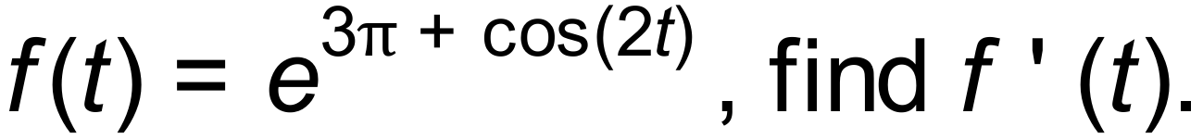 (2 marks)

**(b)** Use the quotient rule to differentiate 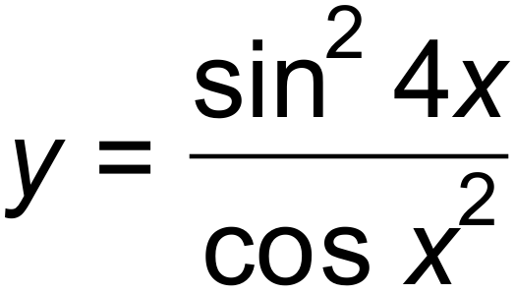 . (Do not simplify your answer.) (2 marks)

**(c)** Find the gradient of the tangent line to the curve of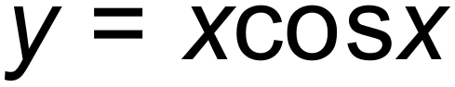 at the point

where . (3 marks)

**Question 6 (5 marks)**

Consider the gradient function 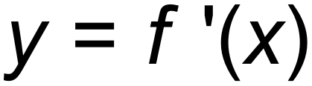 below. The local maximum is at 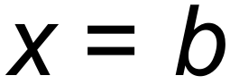 and the local minimum is at 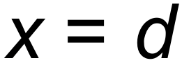. The roots are at 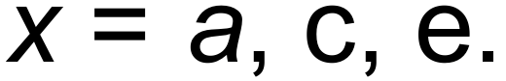

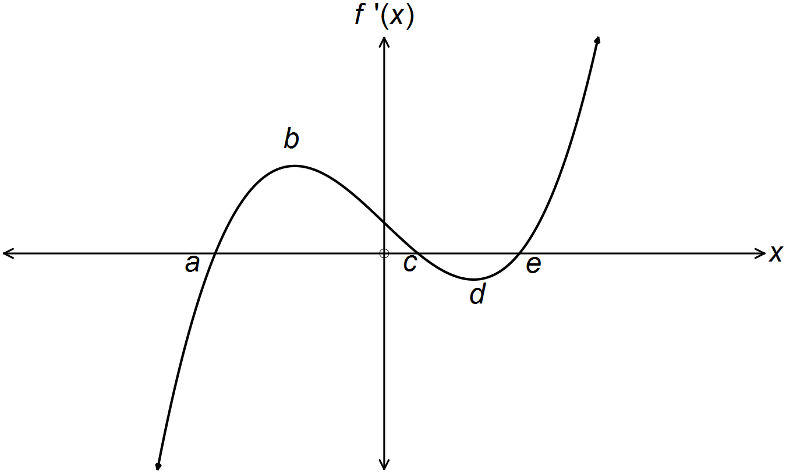

**(a)** At which values of *x* are the points of inflection on the function 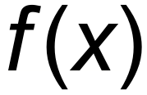? (1 mark)

**(b)** At which value(s) of *x* is/are the local minima on the function ? (1 mark)

**(c)** State the concavity at *c* on the function . (1 mark)

**(d)** Draw the graph of  on the same set of axes. (2 marks)

**Question 7 (11 marks)**

Consider the equation of the curve 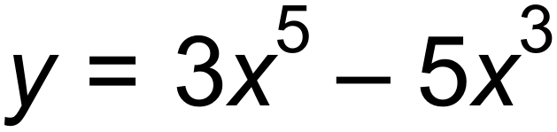.

**(a)** Use calculus to find the coordinates of the stationary points on the curve and

determine the nature of these points. (5 marks)

**(b)** Determine the *x –* value(s) of the inflection point(s) and identify their nature. (3 marks)

***Question 7 (Continued)***

**(c)** Sketch the graph on the axis below. Label the stationary points.

(3 marks)

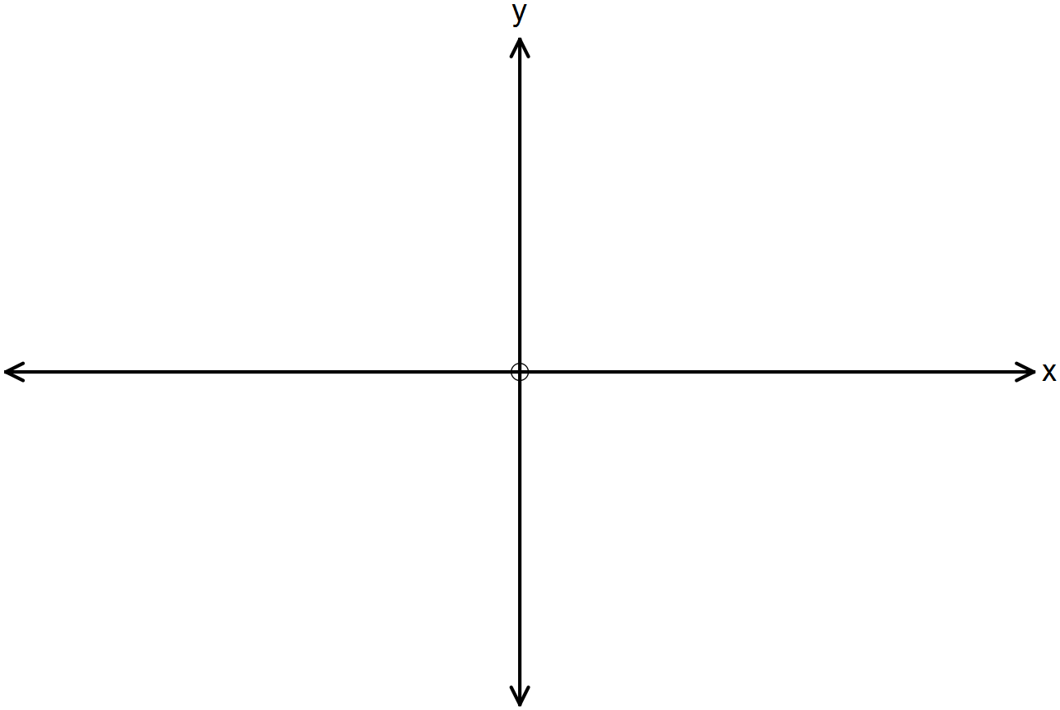

**Question 8 (8 marks)**

**(a)** State the function  if 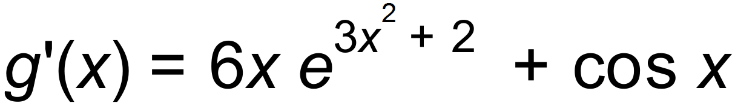 . (2 mark)

**(b)** Determine the antiderivative of 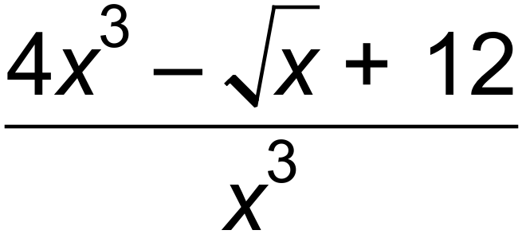 . (2 marks)

**(c)** Determine 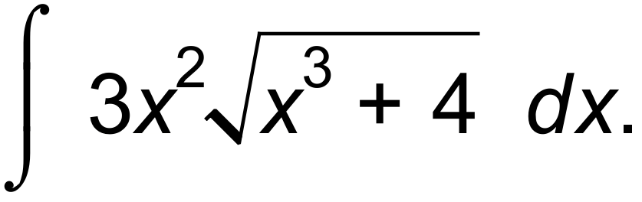 (2 marks)

**(d)** The gradient of a curve is given by 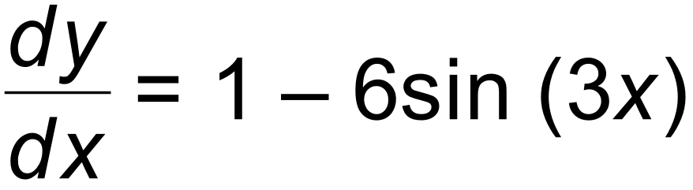.

The curve passes through the point (0, 7). What is the equation of the curve? (2 marks)

**End of Section One**

**Additional working space**

Question number(s): ……………………

**Additional working space**

Question number(s): ……………………

WATP acknowledges the permission of School Curriculum and Assessment Authority in

providing instructions to students.